Name :____________________________________________Signature:___________
P530/1
BIOLOGY
June 2019
2 ½ hours
UGANDA ADVANCED CERTIFICATE OF EDUCATION
Biology
Paper 1
2 hours 30 minutes
Instructions to candidates
Answer all questions in both section A and B
Section A
Answer to this section must be written in the boxes provided.
Section B
Answer to this section should be written in the space provided and not any where else.
No addition sheet of paper should be inserted in this booklet.
For Examiner’s use only
Section A: 1-40
Section B: 41
42
43
44
45
46
Total

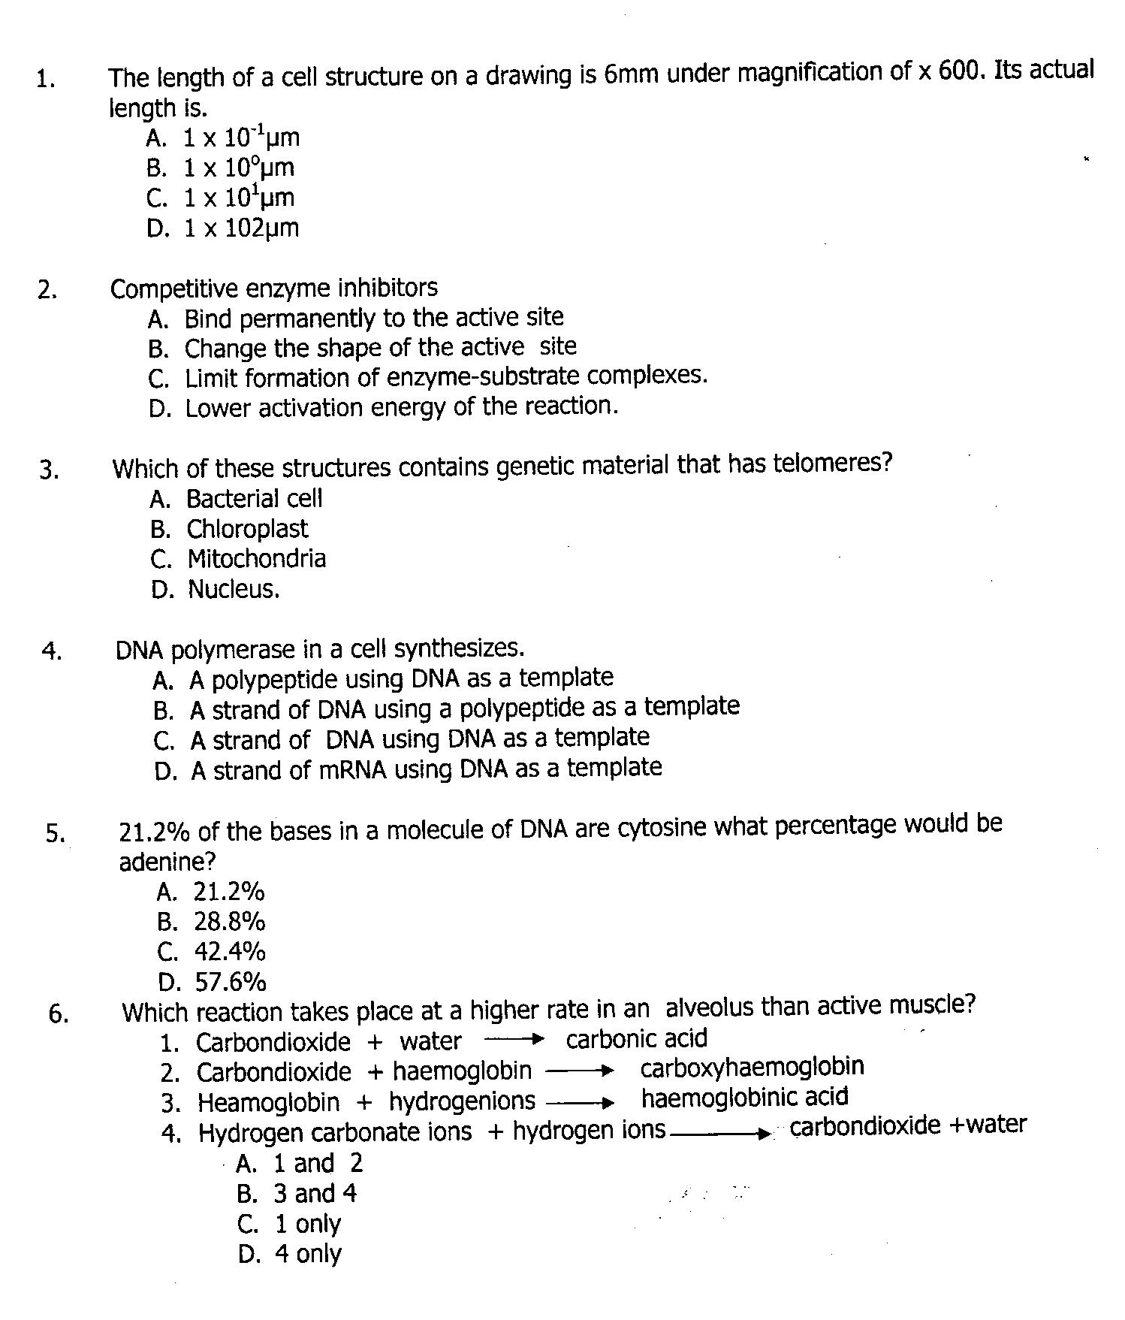

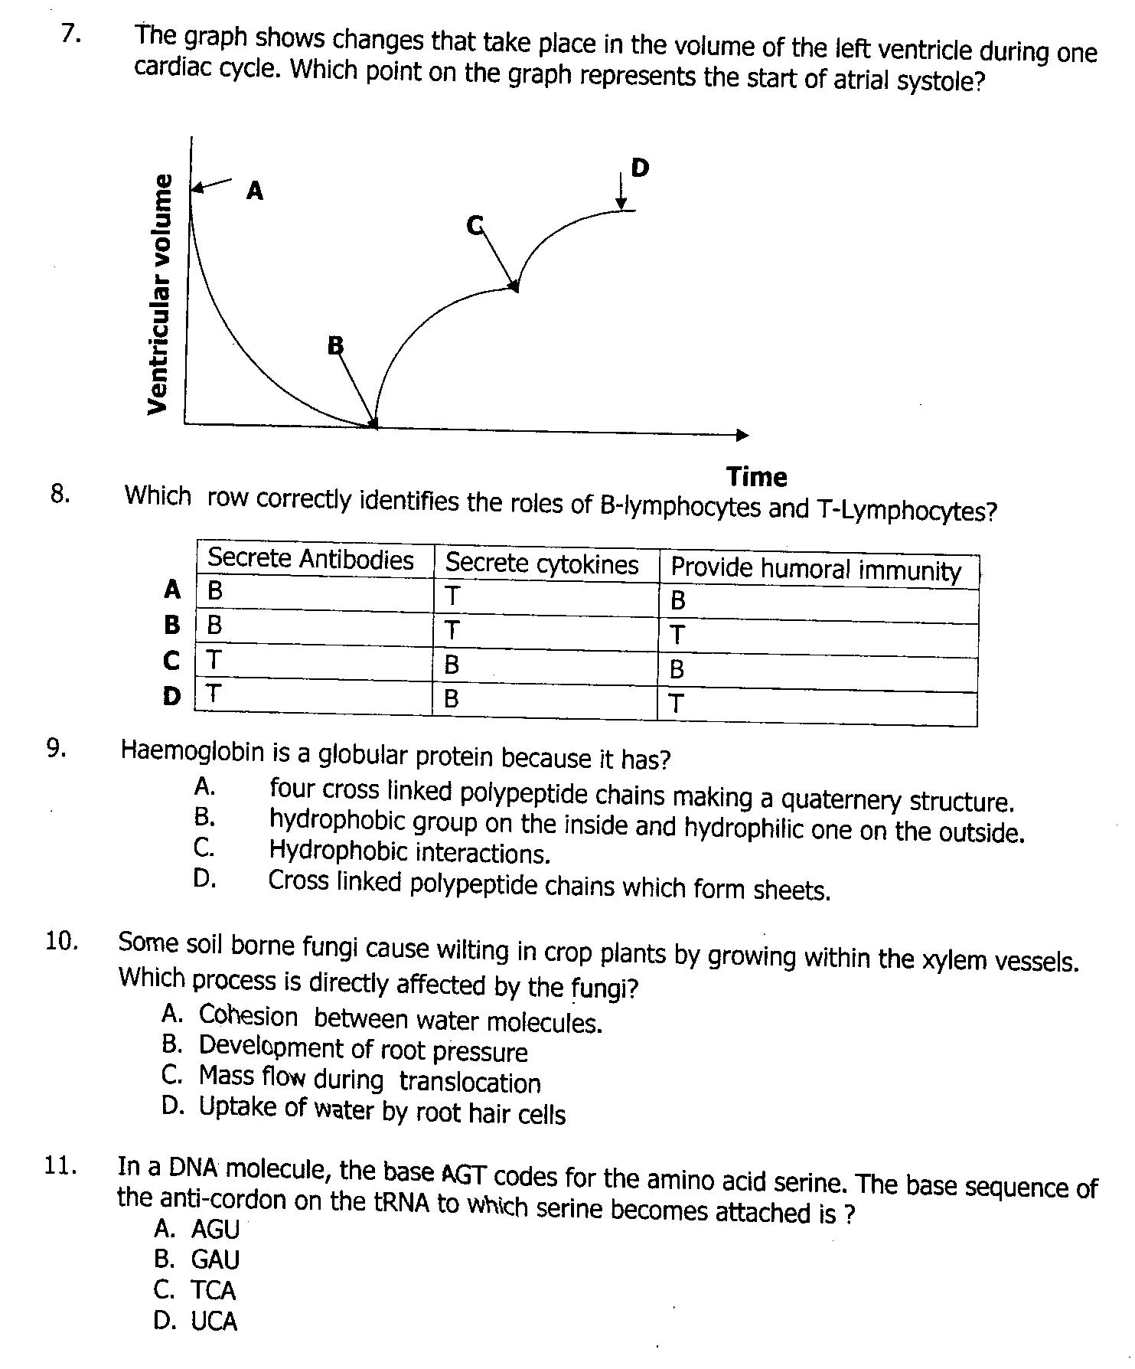

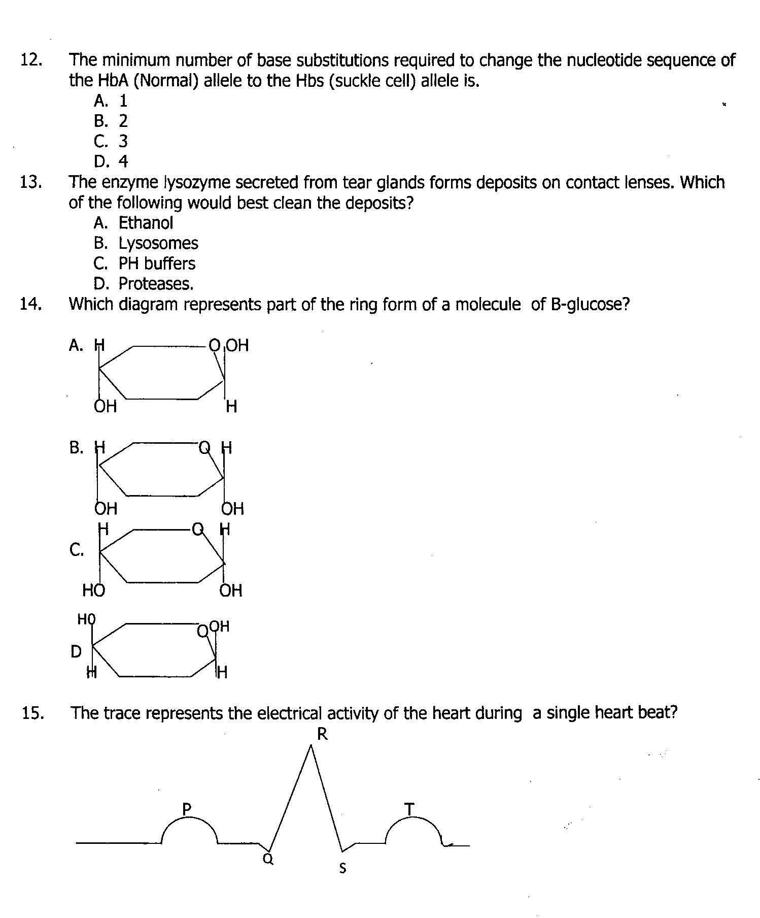

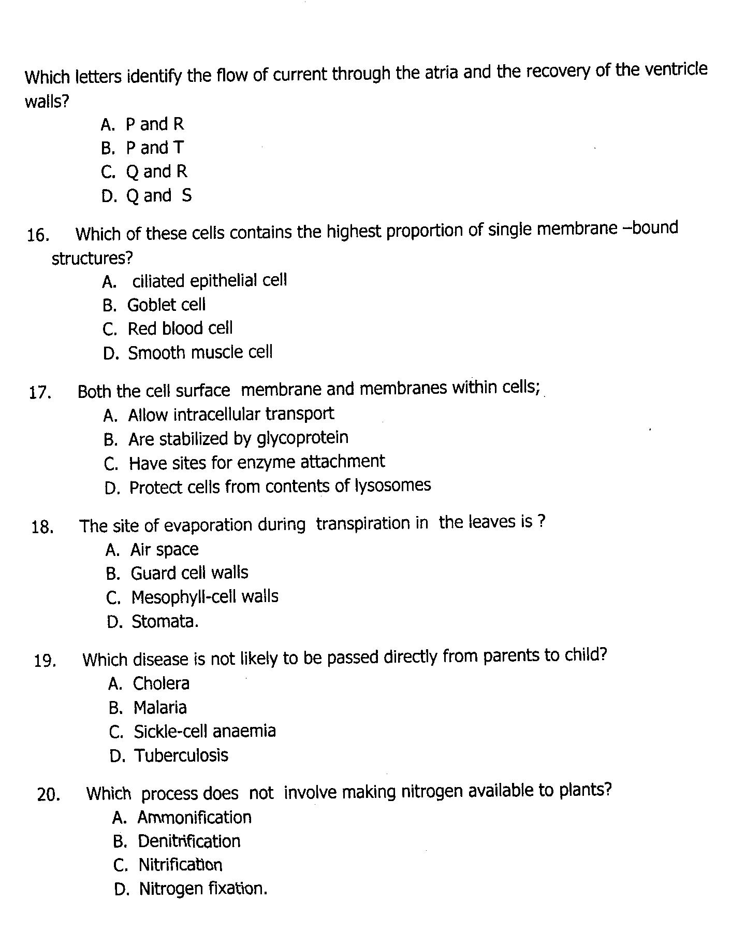

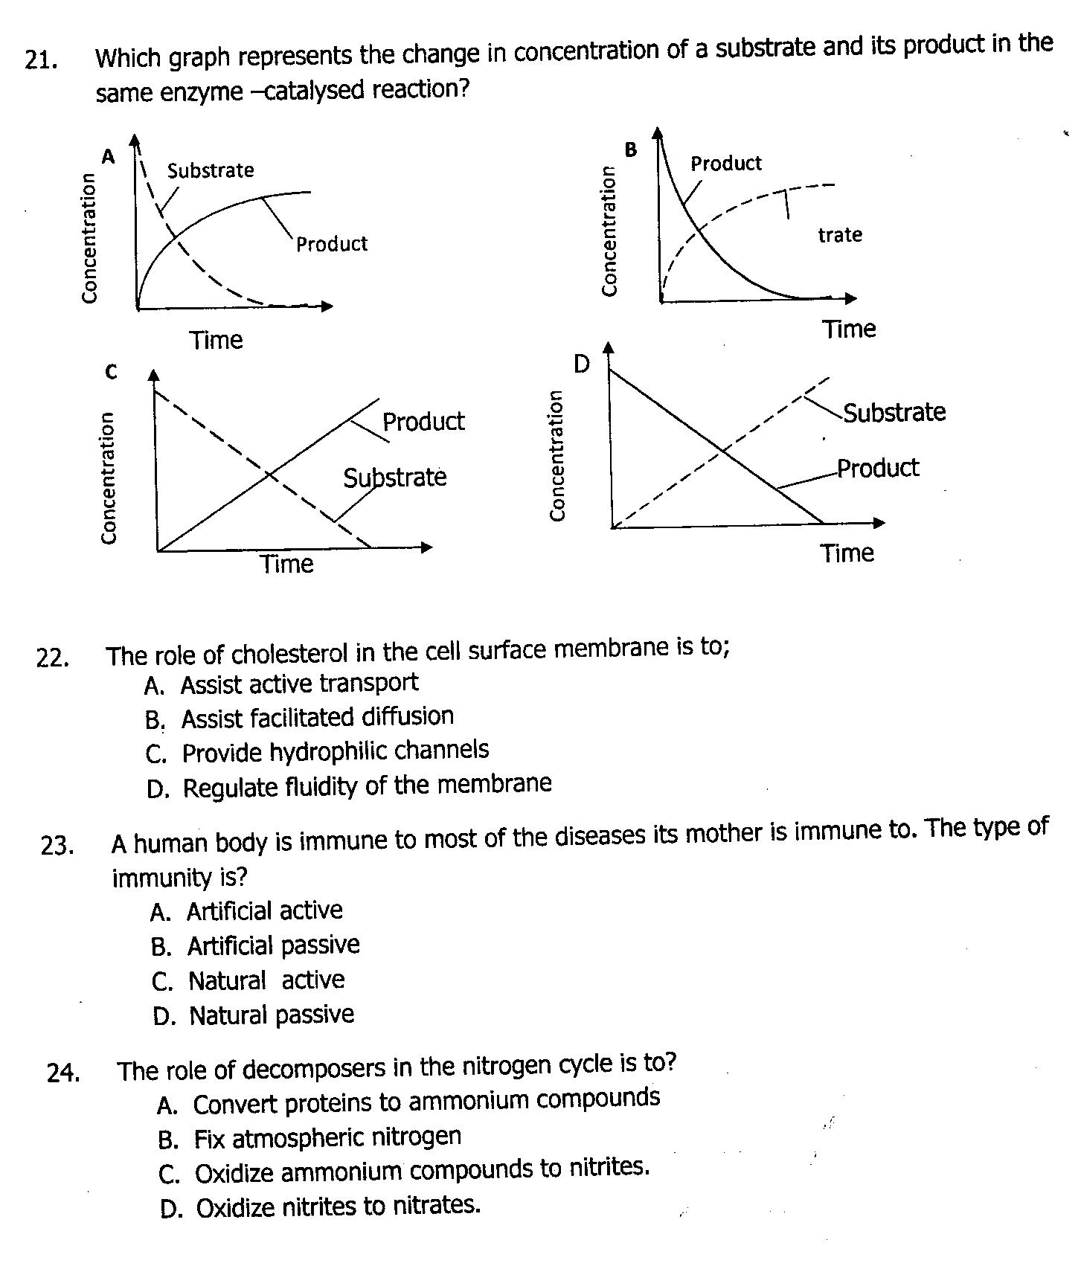

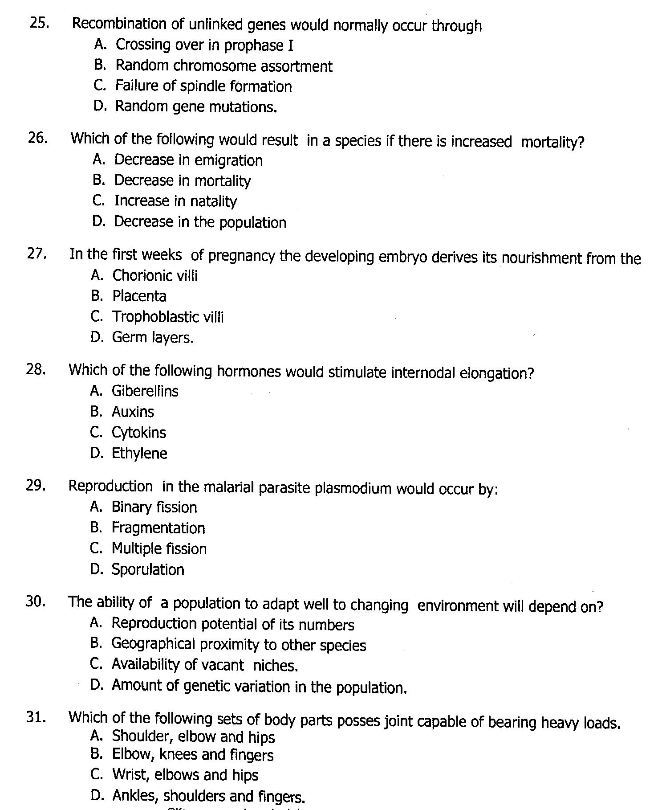
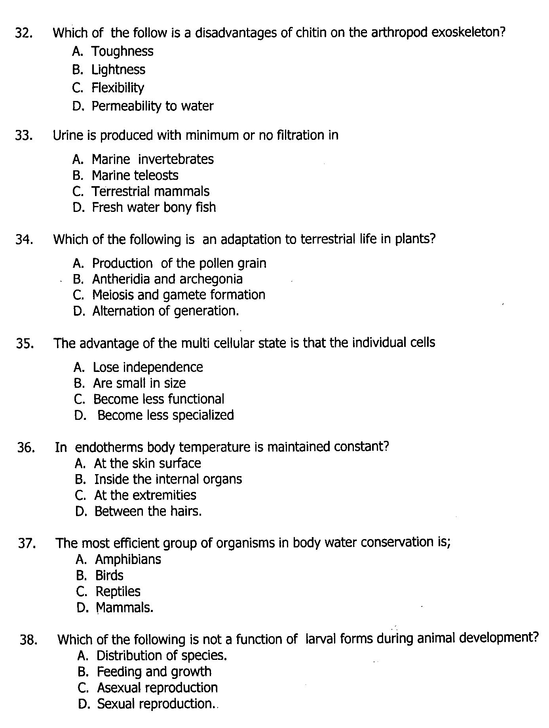
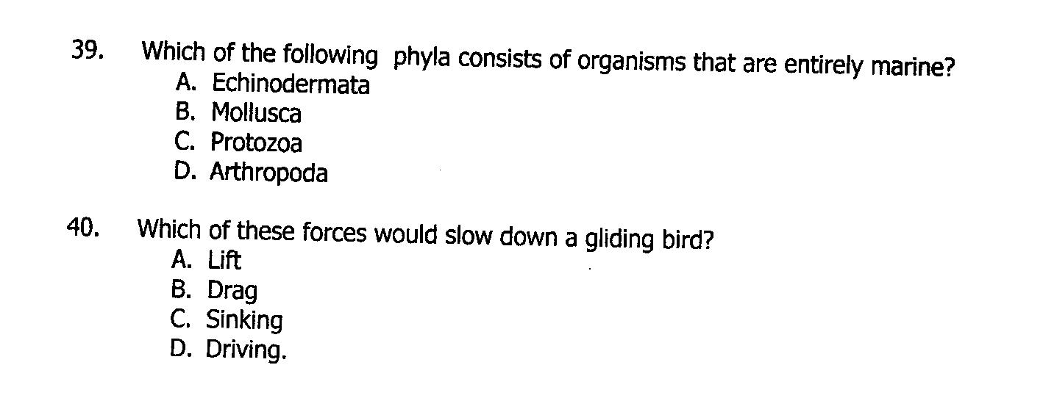

SECTION B
- . The table below shows the thickness of the thickness of the medulla in relation to the rest of the kidney in a number of mammals.
Mammals | Relative thickness | Maximum urine  Concentration (arbitrary units)
Bearer | 1.0 | 52
Pig | 1.3 | 110
Human | 2.6 | 140
Rat | 5.2 | 300
Kangaroo rat | 7.8 | 550
Animal X | 9.8 | 940
- (i) Explain the relationship between urine concentration and the relative thickness of the medulla. (03 marks)
……………………………………………………………………………………………………………………………………………………………………………………………………………………………………………………………………………………………………………………………………………………………………………………………………………………………………………………
(ii) Suggest the natural habitat of : (02 marks)
Bearer ……………………………………………………………………………………………
Animal X ………………………………………………………………………………………..
- (i) State three physiological adaptations of the kangaroo rat to its environment. (03 marks)
………………………………………………………………………………………………………………………………………………………………………………………………………………………………………………………………………………………………………………………………………………………………………………………………………………………………
- With a reason, state the trend of amount of uric acid produced by omnivores, herbivores and carnivorous animals. .(02 marks)
………………………………………………………………………………………………………………………………………………………………………………………………………………………………………………………………………………………………………………………
- Carbohydrates and lipids are useful energy sources in cells.
- Explain the difference in the energy values of carbohydrates and lipids as energy sources .(03 marks)
………………………………………………………………………………………………………………………………………………………………………………………………………………………………………………………………………………………………………………………………………………………………………………………………………………………………
- The table below shows the R.Q values of a mouse at different air temperature
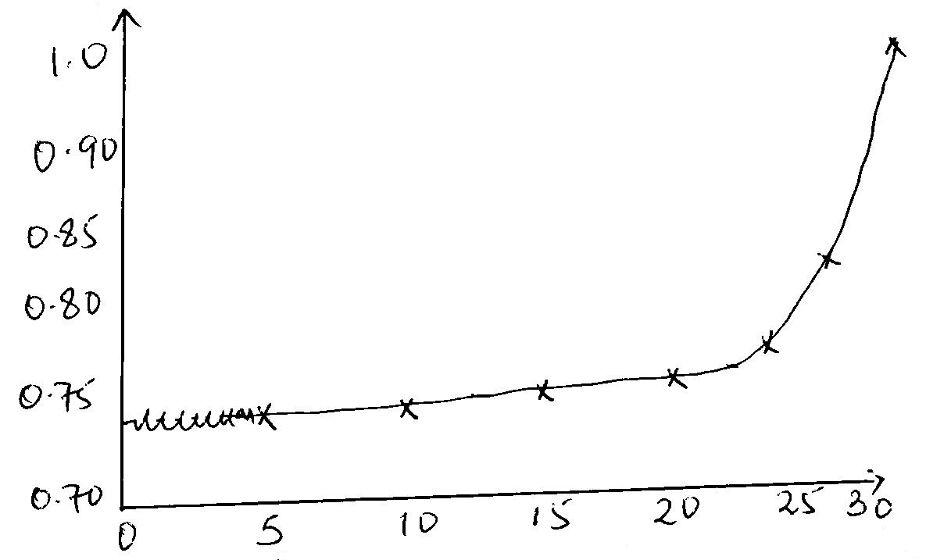

- Using information in the table explain the relationship between RQ and temperature. (04 marks)
………………………………………………………………………………………………………………………………………………………………………………………………………………………………………………………………………………………………………………………………………………………………………………………………………………………………………………………………………………………………………………………………………………………………………………………………………………………………………………………………………………………………………………………………………………………………………………………………………………………………………………………………
- State circumstances under which RQ would use over 1.0. (01 mark)
………………………………………………………………………………………………………………………………………………………………………………………………………………………………………………………………………………………………………………………………………………………………………………………………
- State two reasons why theoretical RQ values of the different food substances are not realistic. (02 marks)
……………………………………………………………………………………………………………………………………………………………………………………………………………………………………………………………………………………………………………………………………………………………………………………………………………………………………………………………………………………………………………
- (a) (i) What is meant by the term feed back mechanism ? (03 marks)
………………………………………………………………………………………………………………………………………………………………………………………………………………………………………………………………………………………………………………………………………………………………………………………………………………………………
(ii) State three functions of homeostatic control in cells (03 marks)
………………………………………………………………………………………………………………………………………………………………………………………………………………………………………………………………………………………………………………………………………………………………………………………………………………………………………………………………………………………………………………………………………………………………………………………………………………………………………………
(b) Explain the role of feed back mechanism in the generation of an action along the axon membrane. (04 marks)
………………………………………………………………………………………………………………………………………………………………………………………………………………………………………………………………………………………………………………………………………………………………………………………………………………………………………………………………………………………………………………………………………………………………………………………………………………………………………………………………………………………………………………………………………………………………………………………………………………………………………………………………
- Descriptive selection occurs in one species of rabbits where in the population large female mate only with large males and vice versa. intermediate have a low survival rate
- (i) Sketch a graph to show the distribution in size of the rabbits as a result of disruptive selection. (03 marks)
………………………………………………………………………………………………………………………………………………………………………………………………………………………………………………………………………………………………………………………………………………………………………………………………………………………………………………………………………………………………………………………………………………………………………………………………………………………………………………
(ii) Explain how disruptive selection has been maintained in this species of rabbit (04 marks)
………………………………………………………………………………………………………………………………………………………………………………………………………………………………………………………………………………………………………………………………………………………………………………………………………………………………………………………………………………………………………………………………………………………………………………………………………………………………………………………………………………………………………………………………………………………………………………………………………………………………………………………………
- Suggest how two different species of rabbit could a rise (03 marks)
………………………………………………………………………………………………………………………………………………………………………………………………………………………………………………………………………………………………………………………………………………………………………………………………………………………………………………………………………………………………………………………………………………………………………………………………………………………………………………………………………………………………………………………………………………………………………………………………………………………………………………………………
- (a) State three adaptations of the circulatory system of a diving mammal (03 marks)
………………………………………………………………………………………………………………………………………………………………………………………………………………………………………………………………………………………………………………………………………………………………………………………………………………………………
(b) Explain why ventilation is initially hampered at high altitude (04 marks)
………………………………………………………………………………………………………………………………………………………………………………………………………………………………………………………………………………………………………………………………………………………………………………………………………………………………………………………………………………………………………………………………………………………………………………………………………………………………………………………………………………………………………………………………………………………………………………………………………………………………………………………………
(c) State three physiological differences between the respiratory system of a human being and an insect (03 marks)
………………………………………………………………………………………………………………………………………………………………………………………………………………………………………………………………………………………………………………………………………………………………………………………………………………………………
- (a) (i) State three differences between carbohydrates and lipids (03 marks)
………………………………………………………………………………………………………………………………………………………………………………………………………………………………………………………………………………………………………………………………………………………………………………………………………………………………………………………………………………………………………………………………………
(ii) State three physiological functions of carbohydrates in plant life. (03 marks)
………………………………………………………………………………………………………………………………………………………………………………………………………………………………………………………………………………………………………………………………………………………………………………………………………………………………………………………………………………………………………………………………………………………………………………………………………………………………………………
(b) Explain how fatty acids are modified to reach the blood stream in mammals. (04 marks)
………………………………………………………………………………………………………………………………………………………………………………………………………………………………………………………………………………………………………………………………………………………………………………………………………………………………………………………………………………………………………………………………………………………………………………………………………………………………………………………………………………………………………………………………………………………………………………………………………………………………………………………………
END

